**Large instance generation**

Gathered TSP instances from <http://comopt.ifi.uni-heidelberg.de/software/TSPLIB95/tsp/>

Also available at <https://github.com/pdrozdowski/TSPLib.Net/tree/master/TSPLIB95>

Optimals from <http://comopt.ifi.uni-heidelberg.de/software/TSPLIB95/STSP.html>

According to (Fischetti et al., 1997) we fix the number of clusters to $m≔\left\lceil n/5\right\rceil$.

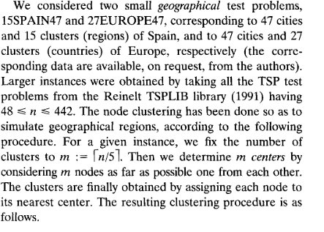

(Fischetti et al., 1997)

(Archetti et al., 2018)

**References**

Archetti, C., Carrabs, F., & Cerulli, R. (2018). The Set Orienteering Problem. *European Journal of Operational Research*, *267*(1), 264–272. https://doi.org/10.1016/j.ejor.2017.11.009

Fischetti, M., González, J. J. S., & Toth, P. (1997). A branch-and-cut algorithm for the symmetric generalized traveling salesman problem. *Operations Research*, *45*(3), 378–394. https://doi.org/10.1287/opre.45.3.378

Reinelt, G. (1991). TSPLIB. A traveling salesman problem library. *ORSA Journal on Computing*, *3*(4), 376–384. https://doi.org/10.1287/ijoc.3.4.376